How to setup away mode of Tenda Smart Plug in Beli APP?

Beli APP is designed to control Tenda Smart Plug locally and also remotely. With Beli app, we can easily control and monitor Tenda Smart Plug wherever we are and make our home smart.

Step1: On the Beli app, go to Devices page, click on SP3, then tap Away icon.

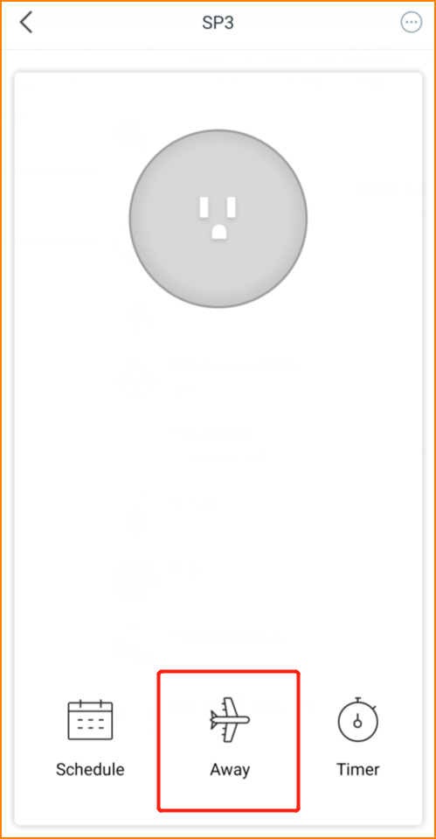

Step2: Set the Start time, end time and repeat. Click “Start” in the end.
Take the picture below for example, the SP3 will turn on the Away mode between 18:00 o’clock to 23:00 o’clock only on Saturday and Sunday. During this period, the device would turn on/off randomly to act like there’s someone at home, so that you can Make your house safer.

